Crafts for the and activity Pages for: “Wolf!”
When doing any of the crafts and activities, PLEASE!! don’t feel like they have to be done exactly as the instructions direct. IMPORVISE! Use supplies you have readily available and by all means, Have Fun!

Easy Barnyard Animal Bookmarks
https://www.theottoolbox.com/big-red-barn-book-craft/

Free Printable Barnyard Animal Bookmarks
https://www.sunnydayfamily.com/2016/09/farm-animal-bookmarks.html?m=1

Variety of Wolf Crafts, but the one that really caught my eye was the Stand-up Wolf
https://www.artistshelpingchildren.org/wolfcraftsideasactivitieskids.html

Variety of Reading Animal Crafts, (ignore the word “Preschool” please!)
https://homeschoolpreschool.net/cow-crafts-for-preschoolers/

Please have Fun and share your creations! They can be like these above, or whatever you come up with. Send pictures to: libraryinlamar@gmail.com or upload a picture to our Facebook page.

We look forward to seeing your creations!

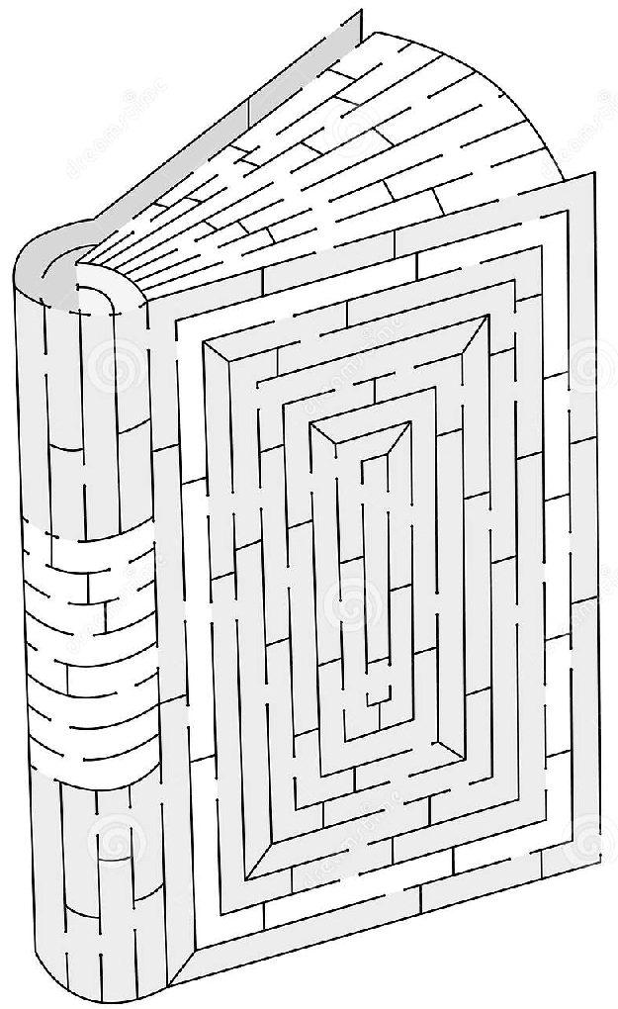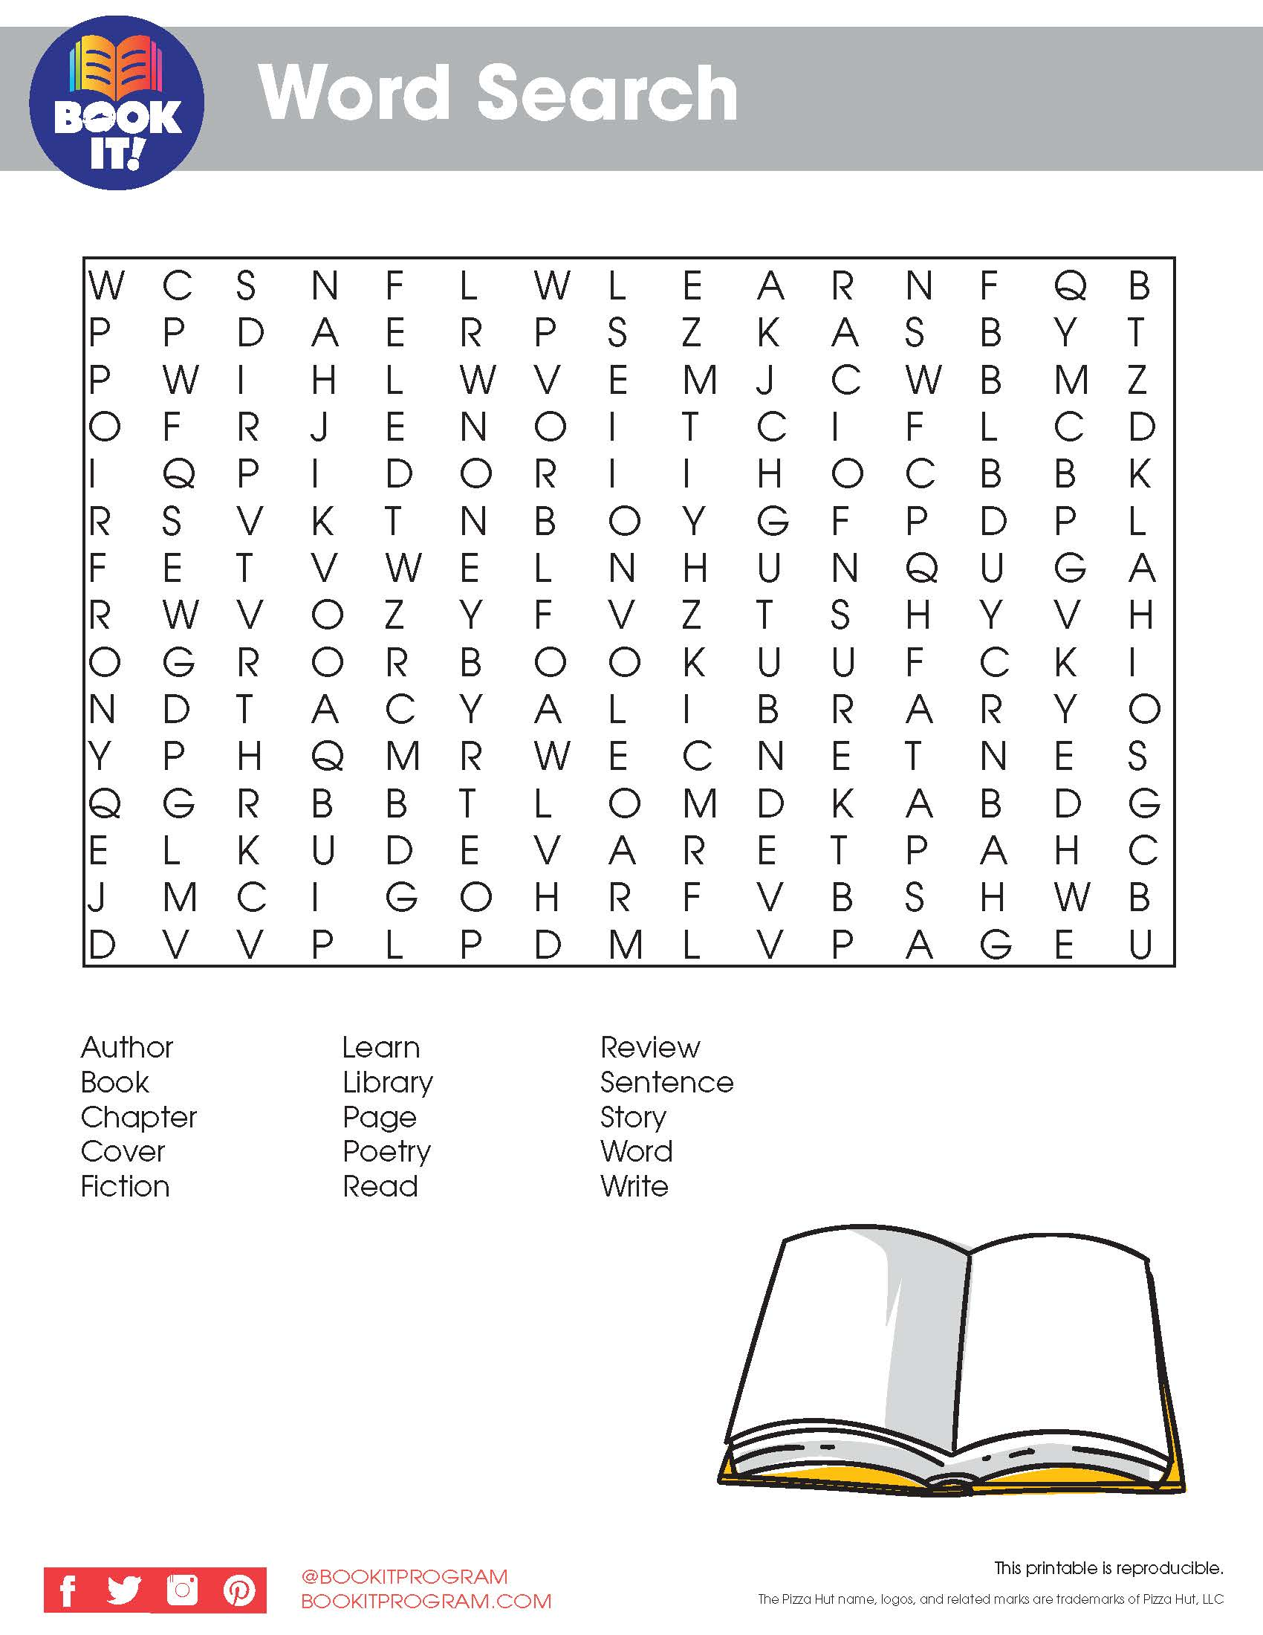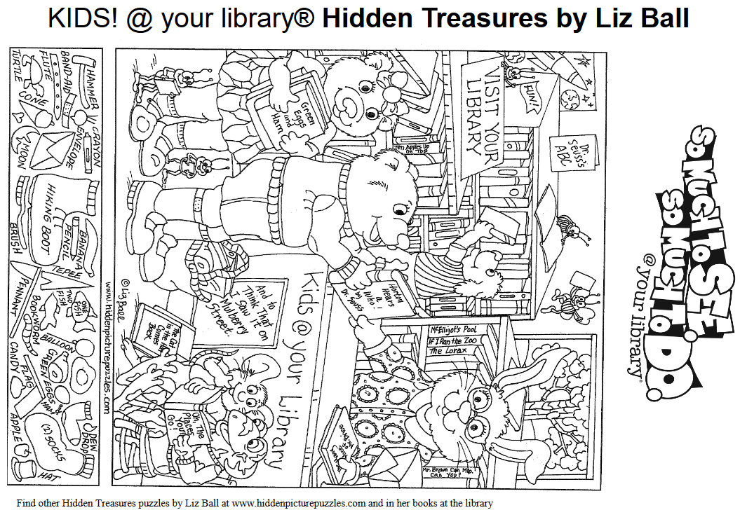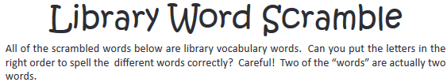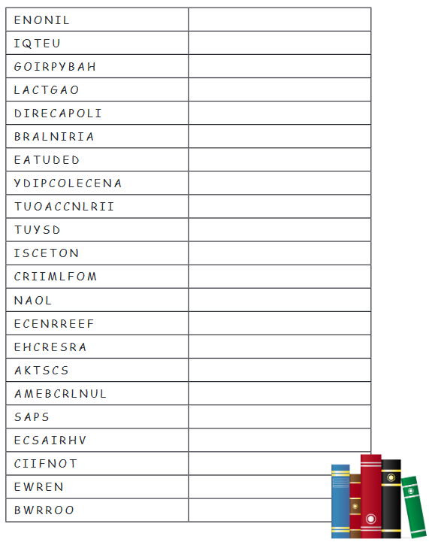
Word Bank
archives biography borrow call number catalog circulation due date
encyclopedia fiction librarian loan microfilm online pass periodical quiet reference renew research section stacks study 