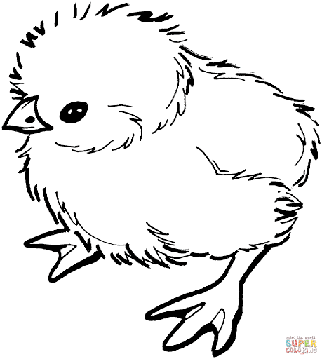

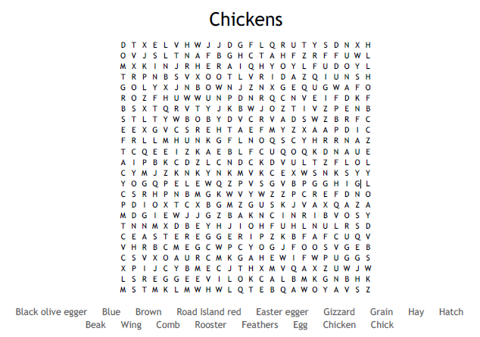

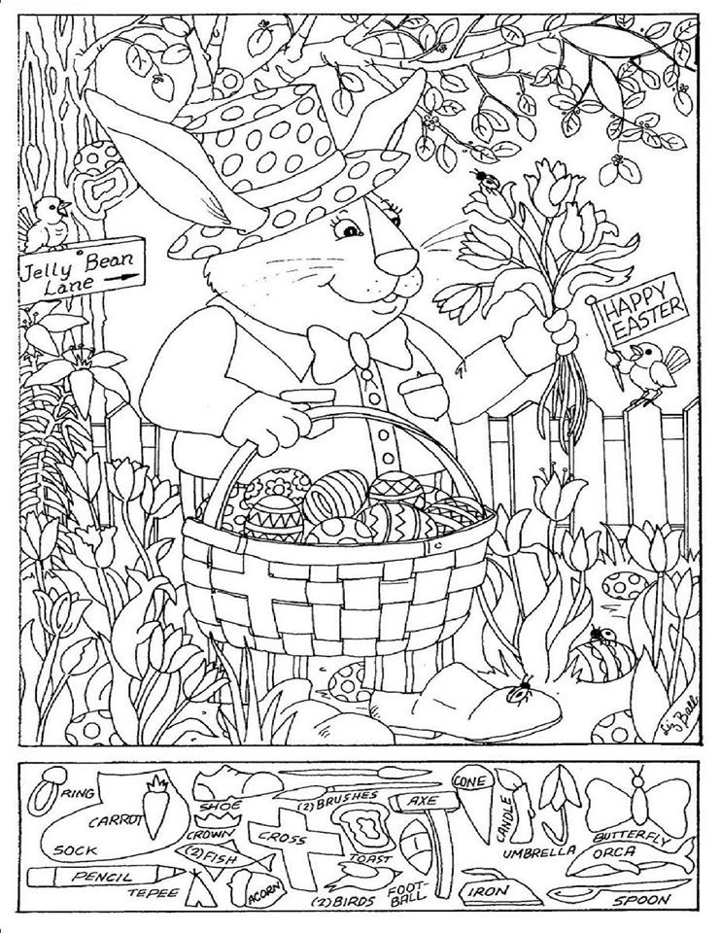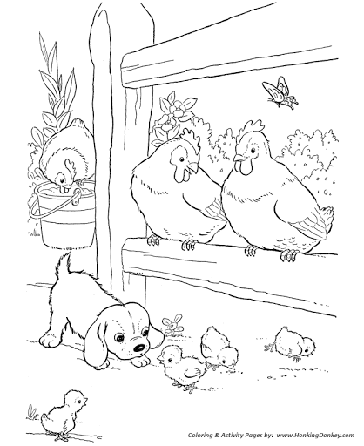

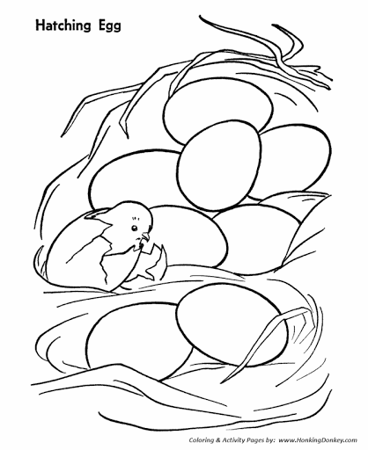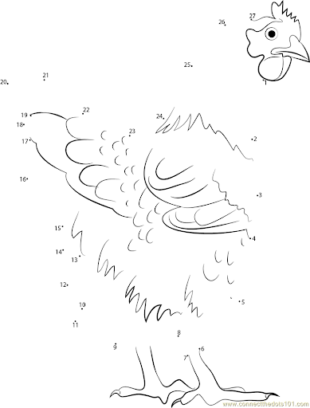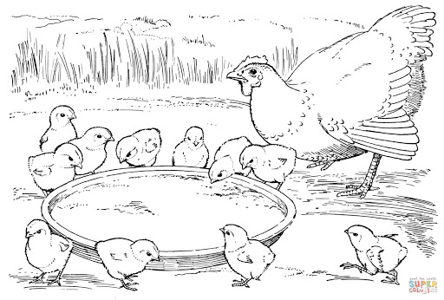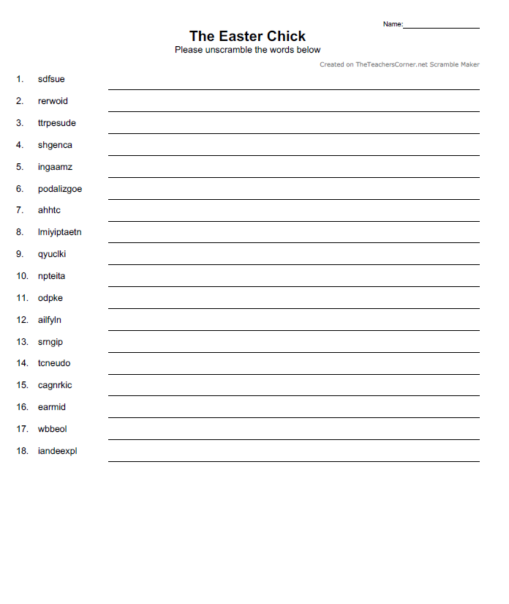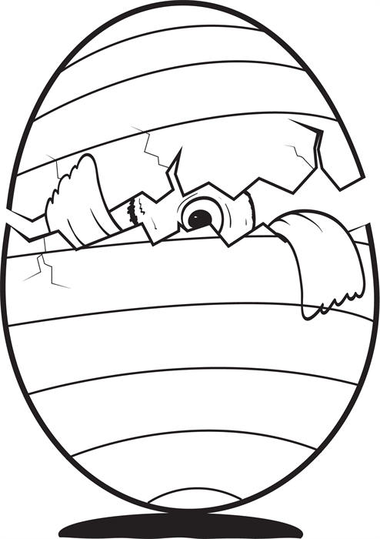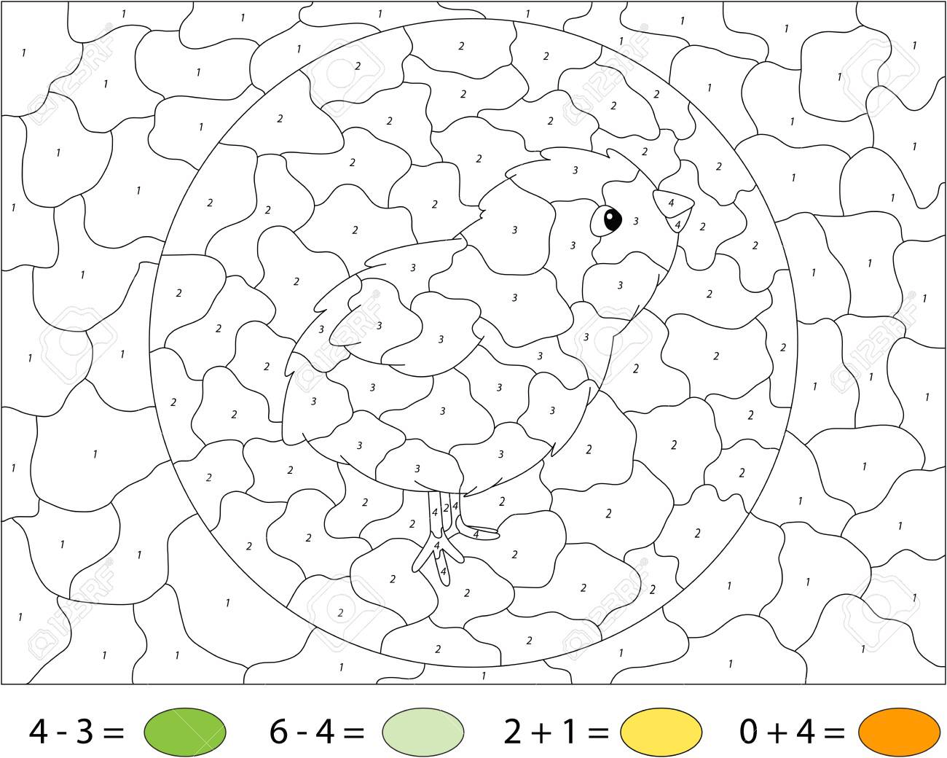

**Orange**

**Yellow**

**Light**

**Green**

**Green**

fussed apologized hatch impatiently

worried quickly patient poked

sputtered finally spring counted

changes cracking admire wobble

amazing explained

apologized

hatch

impatiently

quickly

patient

poked

finally

spring

counted

cracking

admire

wobble

explained

**Chick Hatching Craft – Try one of these!!**

<https://onelittleproject.com/peekaboo-clothespin-eggs/>

<https://www.muminthemadhouse.com/easter-chick-card-with-pop-out-beak/>

<https://www.easypeasyandfun.com/surprise-easter-eggs-craft/>

***Have Fun!***